Master
- MCP Servers to be implemented
- Doc Verification
- Credit bureau
- Banking
- Employment Verification
- Notification * (to be implemented)
- Skills to be implemented
  - pii_redactor_skill
  - dti_calculator_skill
  - fraud_detection_skill
  - income_verify_skill
  - risk_scoring_skill
  - employment_stability_modifier skill * (to be implemented)
  - explanation_skill
- Dataset for Loan application and all MCPs - customer_id acts as param to fetch records
  - Applicant 1 to 15 (Prime / Auto-Approve): Designed with high incomes, long credit history (60–240 months), high credit scores (740–850), $0$ delinquencies, and strong bank balances.
  - Applicant 16 to 30 (Thin Credit / Human Escalation): Young borrowers with short credit history lengths (2–9 months) and middle-tier scores (600–660).
  - Applicant 31 to 40 (High DTI / Escalation or Reject): Moderate earners applying for oversized loans ($60k–$95k), resulting in a Debt-to-Income ratio well above the industry standard 40% threshold.
  - Applicant 41 to 46 (Fraud Signals / Hard Auto-Reject):
    - Income Mismatch
    - Short History / High Score Anomaly
    - Large Borrowing Limit: Applicants requesting over $100k with weak underlying assets and short employment tenures.
  - Applicant 47 to 50 Missing Documents Profile
    - Document Storage file returns an "INCOMPLETE" status vector mapping to missing structural ID cards or pay stubs.
  - Applicant 51 to 54 Terminated Employee (Hard Auto-Reject)
    - If employment_status == "Terminated", the application routes to Auto-Reject, completely bypassing the calculation
Features evaluated to arrive at a decision
1. Credit Bureau Profile Features (Weight: High)
- Credit Score: The core numeric signal. A higher score heavily weighs the composite score upward, while a score below certain thresholds accelerates rejection.
- Credit History Length: The age of the credit file. A short history length, paired with a deceptively high credit score triggers an immediate fraud flag
- Derogatory Marks & Delinquencies: The presence of past missed payments or collections, which significantly penalizes the baseline risk score.
- Total Tradelines: Indicates the depth and variety of the applicant's credit experience.

2. Cash Flow & Income Features (Weight: High)
- Bank-Verified Income: The agent calculates a 3-month rolling average of actual monthly deposits. This acts as the "ground truth" income. This is compared with declared_income_monthly
- Income Volatility: Compares month-over-month variances in deposits. High volatility or unstable deposit patterns penalize the internal income stability score.
- Average Monthly Withdrawals & Account Balance: Measures baseline liquidity to ensure the applicant isn't living constantly at a zero-balance threshold.

3. Debt-to-Income (DTI) Ratio (Weight: Medium-High)
Calculated as a pure, deterministic function by the dti_calculator_skill
- {DTI} = Total Monthly Debt Obligations/Gross Monthly Income
- The agent maps this percentage into risk bands (Low, Moderate, High). A high DTI (typically > 40%-50%) heavily suppresses the composite score, routing even high-credit applicants into human review or auto-rejection.

4. Deterministic Fraud Signals (Weight: Critical Overrides)
The fraud_detection_skill evaluates specific synthetic and behavioral rules. If any of these are triggered, they act as an immediate circuit-breaker, bypassing positive credit indicators to issue an auto-reject or a dedicated compliance interrupt:
- Income Mismatch Ratio: Triggers if the applicant's self-reported income on the intake form is 2 times the verified income found in banking deposit statements.
- Credit Anomaly Trigger: Triggers if the file shows a credit history length of 6 months alongside a premium credit score of 780 (a classic pattern of synthetic identity clustering).
- Demographic Violations: Rule-based checks, such as an applicant being under the age of 21 while requesting a large loan amount 100,000
- Unemployed: Employment Status is inactive

1. Composite Score Logic (0–100)
A robust financial scoring logic balances Credit Profile (40%), Affordability/DTI (30%), and Cash Flow Stability (30%).
Below is the structured formula matrix to implement inside your node:

Component Breakdown & Normalization Logic:
- Credit Component () — Weight: 40%
  - Rule: Scale the FICO score linearly between 300 and 850 to get a base out of 100, then apply a heavy penalty (e.g., -20 points) for each historical delinquency mark. Cap the minimum component score at 0.
- Debt-to-Income Component ($$S_{\text{DTI}}$) — Weight: 30%
  - Formula: Calculated deterministically by the dti_calculator_skill:

  - Scoring Assignment:
    - DTI ≤ 0.30 → SDTI = 100
    - 0.30 < DTI ≤ 0.45 → SDTI = 60
    - 0.45 < DTI ≤ 0.55 → SDTI = 30
    - DTI > 0.55 → SDTI = 0
- Cash Flow Component (SCashFlow) Rules
Measures verified liquidity using baseline buffers and historical financial spending patterns:
- Savings Buffer Metric (Max 50 Points): If current_balance > (2 * loan_amount) → award maximum baseline of 50 points, otherwise scale proportionally.

- Burn Rate Metric (Max 50 Points): If average_monthly_deposits > average_monthly_withdrawals → award an additional 50 points. If the applicant consistently spends more than they deposit, award 0 points for this sub-metric.

- You can define an Employment Stability Modifier (α) based on tenure ranges:
Tenure Range | Stability Risk Tier | Modifier Value (α)
< 6 months | High Risk (Probationary) | 0.85 (15% penalty to base score)
6 - 24 months | Medium Risk (Establishing) | 1.00 (Neutral / No change)
> 24 months | Low Risk (Stable Career) | 1.05 (5% stability bonus)

{Final Risk-Adjusted Score} = Sbase * (α)

Note: If your fraud_detection_skill sets any fraud boolean flags to True, the router will immediately short-circuit this node and bypass the computation to assign a hard final verdict of Auto-Reject.

Multi-Agent System
- Orchestrator Agent
- Gatekeeper Agent
- Financial Analysis Agent
- Fraud and Compliance Agent

Step 1: Application Intake & PII Tokenization
- Trigger Data: The Orchestrator Agent takes a row-by-row simulation from main_applications_final.csv.
- Action: It passes the payload to the Gatekeeper Agent. The gatekeeper executes its pii_redactor_skill, masking the raw ssn, dob, phone_number, and home_address text strings, replacing them with safe system tokens inside the graph state.

Step 2: The Document Completeness Check
- Trigger Data: The Gatekeeper Agent hits your simulated object store (document_storage_mcp_final.json) using the primary token parameter cust_id.
- Action: * For Rows 1 to 46, the MCP returns a "document_vault_status": "COMPLETE" payload. The Gatekeeper passes a green-light status back to the Orchestrator.
  - For Rows 47 to 50, the MCP flags "document_vault_status": "INCOMPLETE". The graph throws an interrupt() state. It pauses and waits for the Human Input payload (either RESUME with manual underwriter overrides or REJECT to trigger an incomplete-notice letter).

Step 3: Parallel Financial & Fraud Analysis
Once a profile is cleared by the gatekeeper, the Orchestrator concurrently routes the anonymized context to two parallel processing units:
- The Financial Analyst Agent:
  - Queries credit_bureau_mcp_final.csv to pull credit score metrics and active tradelines.
  - Queries banking_mcp_final.csv and employment_mcp_final.csv via its income_verify_skill to cross-examine deposit logs against stated income records.
    - Variance_Percentage = abs(Declared_Income - Verified_Income) / Verified_Income * 100 [ >100% - fraud]
  - Runs the dti_calculator_skill pure code function to evaluate active monthly debt.
  - Runs the employment_stability_modifier to calculate the
  - Rows 41 & 44 trip the rule: declared_income > 2 * verified_income. - caught by the financial analyst agent, writes a fraud_flag = True marker directly into the graph state object.
- The Fraud & Compliance Agent:
  - Runs your explicit circuit-breaker checks against the row characteristics.
  - Rows 42 & 45 trip the rule: credit_history_length < 6 months and credit_score > 780.
  - Rows 43 & 46 trip the rule: age < 21 and loan_amount > 100000.
  - Rows 51 - 54 trip the rule: employment_status == "Terminated"
  - Result: If any rule matches, it writes a fraud_flag = True marker directly into the graph state object.

Step 4: Component Risk Aggregation & Routing
- Action: The Orchestrator collects both agent frames and pushes them into your risk_scoring_skill. This node computes the multi-factor weighted formula (0–100).
- The Conditional Router:
  - If a Fraud Flag is present (Rows 41-46) or the score lands < 40 (e.g., your high-debt records in Rows 31–40), it routes instantly to Auto-Reject.
  - If the score lands 40-69 (e.g., your thin credit records in Rows 16–30), it triggers an escalation pause for manual underwriting review.
  - If the score lands > 70 (e.g., your premium profiles in Rows 1–15), it paths smoothly to Auto-Approve.

Step 5: Explanations Agent
- Action: The Orchestrator Agent invokes the final explanation_skill.
- Output: It generates regulatory ECOA-aligned explanation objects mapping key factors (e.g., ["Strong credit history", "Low DTI"] for approved loans or ["High Debt-to-Income ratio"] for rejections).

Metadata
Independent MCP Server Checks
npx @modelcontextprotocol/inspector python .agents\\mcp\\doc_verification_server.py
npx @modelcontextprotocol/inspector python .agents\\mcp\\credit_bureau_server.py
npx @modelcontextprotocol/inspector python .agents\\mcp\\banking_server.py
npx @modelcontextprotocol/inspector python .agents\\mcp\\employment_server.py

Modifications
- dti_calculator_skill: input should come from mcp server
- pii_redactor_skill: input should come from mcp server
- risk_scoring_skill: Credit Profile Matrix - from mcp server
- income_verify_skill: input should come from mcp server
- fraud_detection_skill: input should come from mcp server

- explanation_skill: Need to validate and decide llm usage
- risk_scoring_skill: Need to validate
- fraud_detection_skill: Employment Status - Terminated ; auto-reject
- risk_scoring_skill: Update final formula to accommodate employment tenure
- Keep in mind this whole system is for employees ; not for self-employed

Tasks

Implementation
Implementation Process

1.⁠ ⁠Define Graph State Schema – Model a shared state object containing: raw payload, PII-tokenized fields, document_vault_status, fraud_flag, credit/income/employment lookup results, DTI score, component scores, composite risk score, and routing decision. This is your single source of truth flowing between nodes.

2.⁠ ⁠Build Each Agent as a Graph Node
•⁠ ⁠Gatekeeper Node: Takes raw payload → calls PII redactor → replaces SSN/DOB/phone/address with tokens → queries document_storage_mcp_final.json by cust_id → returns COMPLETE or raises interrupt() for INCOMPLETE.
•⁠ ⁠Financial Analyst Node: Reads credit bureau CSV, banking CSV, employment CSV → runs income_verify_skill (variance check, >100% = fraud_flag) → runs dti_calculator_skill → writes fraud_flag for rows 41/44.
•⁠ ⁠Fraud & Compliance Node: Applies three circuit-breaker rules (credit age < 6mo + score > 780, age < 21 + loan > 100k, employment == "Terminated") → writes fraud_flag.
•⁠ ⁠Risk Scorer Node: Aggregates all component scores into weighted formula (0–100).

3.⁠ ⁠Implement Conditional Router – After scoring, branch on:
•⁠ ⁠fraud_flag == True or score < 40 → Auto-Reject
•⁠ ⁠score 40–69 → escalation pause (human-in-loop)
•⁠ ⁠score ≥ 70 → Auto-Approve

4.⁠ ⁠Orchestrator as a State Machine / Directed Graph – Sequence:
1.⁠ ⁠Intake → Gatekeeper (sync)
2.⁠ ⁠If COMPLETE → fan-out Financial + Fraud in parallel (async/concurrent)
3.⁠ ⁠Join → Risk Scorer → Conditional Router
5.⁠ ⁠Human-in-Loop Handling – For INCOMPLETE docs and score 40–69 cases, implement interrupt() with a RESUME/REJECT input mechanism that either injects overrides or terminates with a letter.
6.⁠ ⁠Row-by-Row Simulation Driver – Loop over main_applications_final.csv, feed each row as a separate graph invocation with a unique correlation ID. Log every transition, flag, and decision for traceability.
7.⁠ ⁠Integration & Edge Case Testing – Test all 54+ rows end-to-end, verifying: rows 1–15 auto-approved, 16–30 manual review, 31–40 auto-rejected, 41–46 fraud-detected, 47–50 incomplete-doc interrupted, 51–54 employment-terminated rejected.

Challenges we might face while implementing

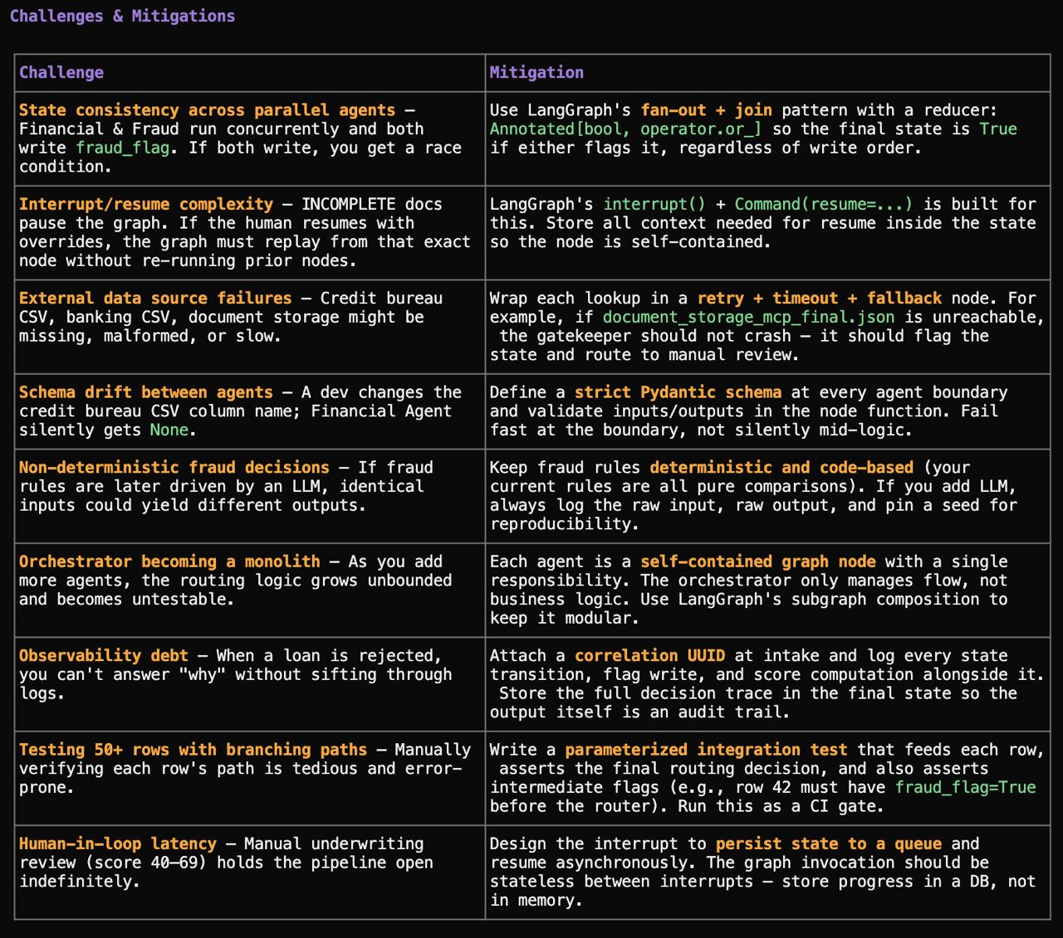

Challenges we might face while building agents separately and combining them

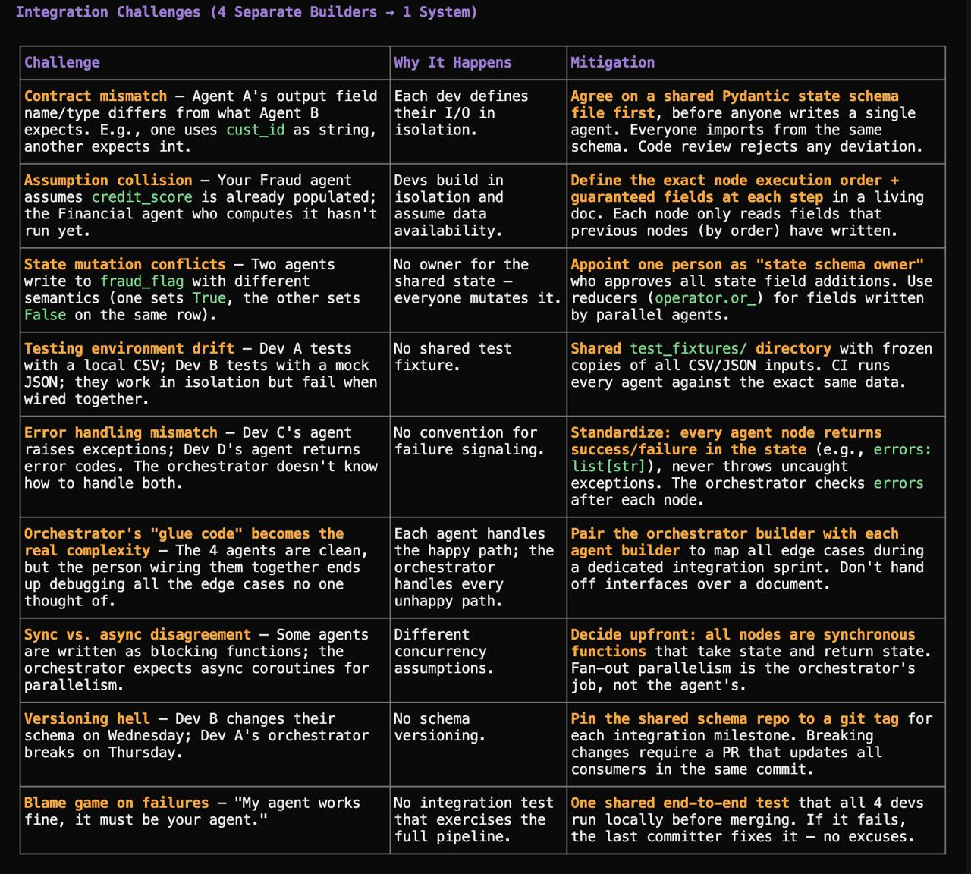

Defining graph state schema
Use LangGraph (Python) — it's purpose-built for this exact pattern. Define your state schema as a TypedDict or Pydantic BaseModel listing every field the pipeline touches (raw payload, tokenized fields, document_vault_status, fraud_flag, credit data, DTI, component scores, composite score, routing decision). You annotate fields as Optional where they get populated mid-pipeline and use Annotated[... , add_messages] reducer annotations for append-only fields (e.g., log entries).
If you're in the Google ecosystem, Google ADK also supports agent state management natively with State objects passed through agent calls — but LangGraph has the richer graph semantics (fan-out, conditional edges, interrupts, parallel execution) that match your spec exactly.

